The Nuremberg Trials
(Nov 20, 1945 – Oct 1, 1946)

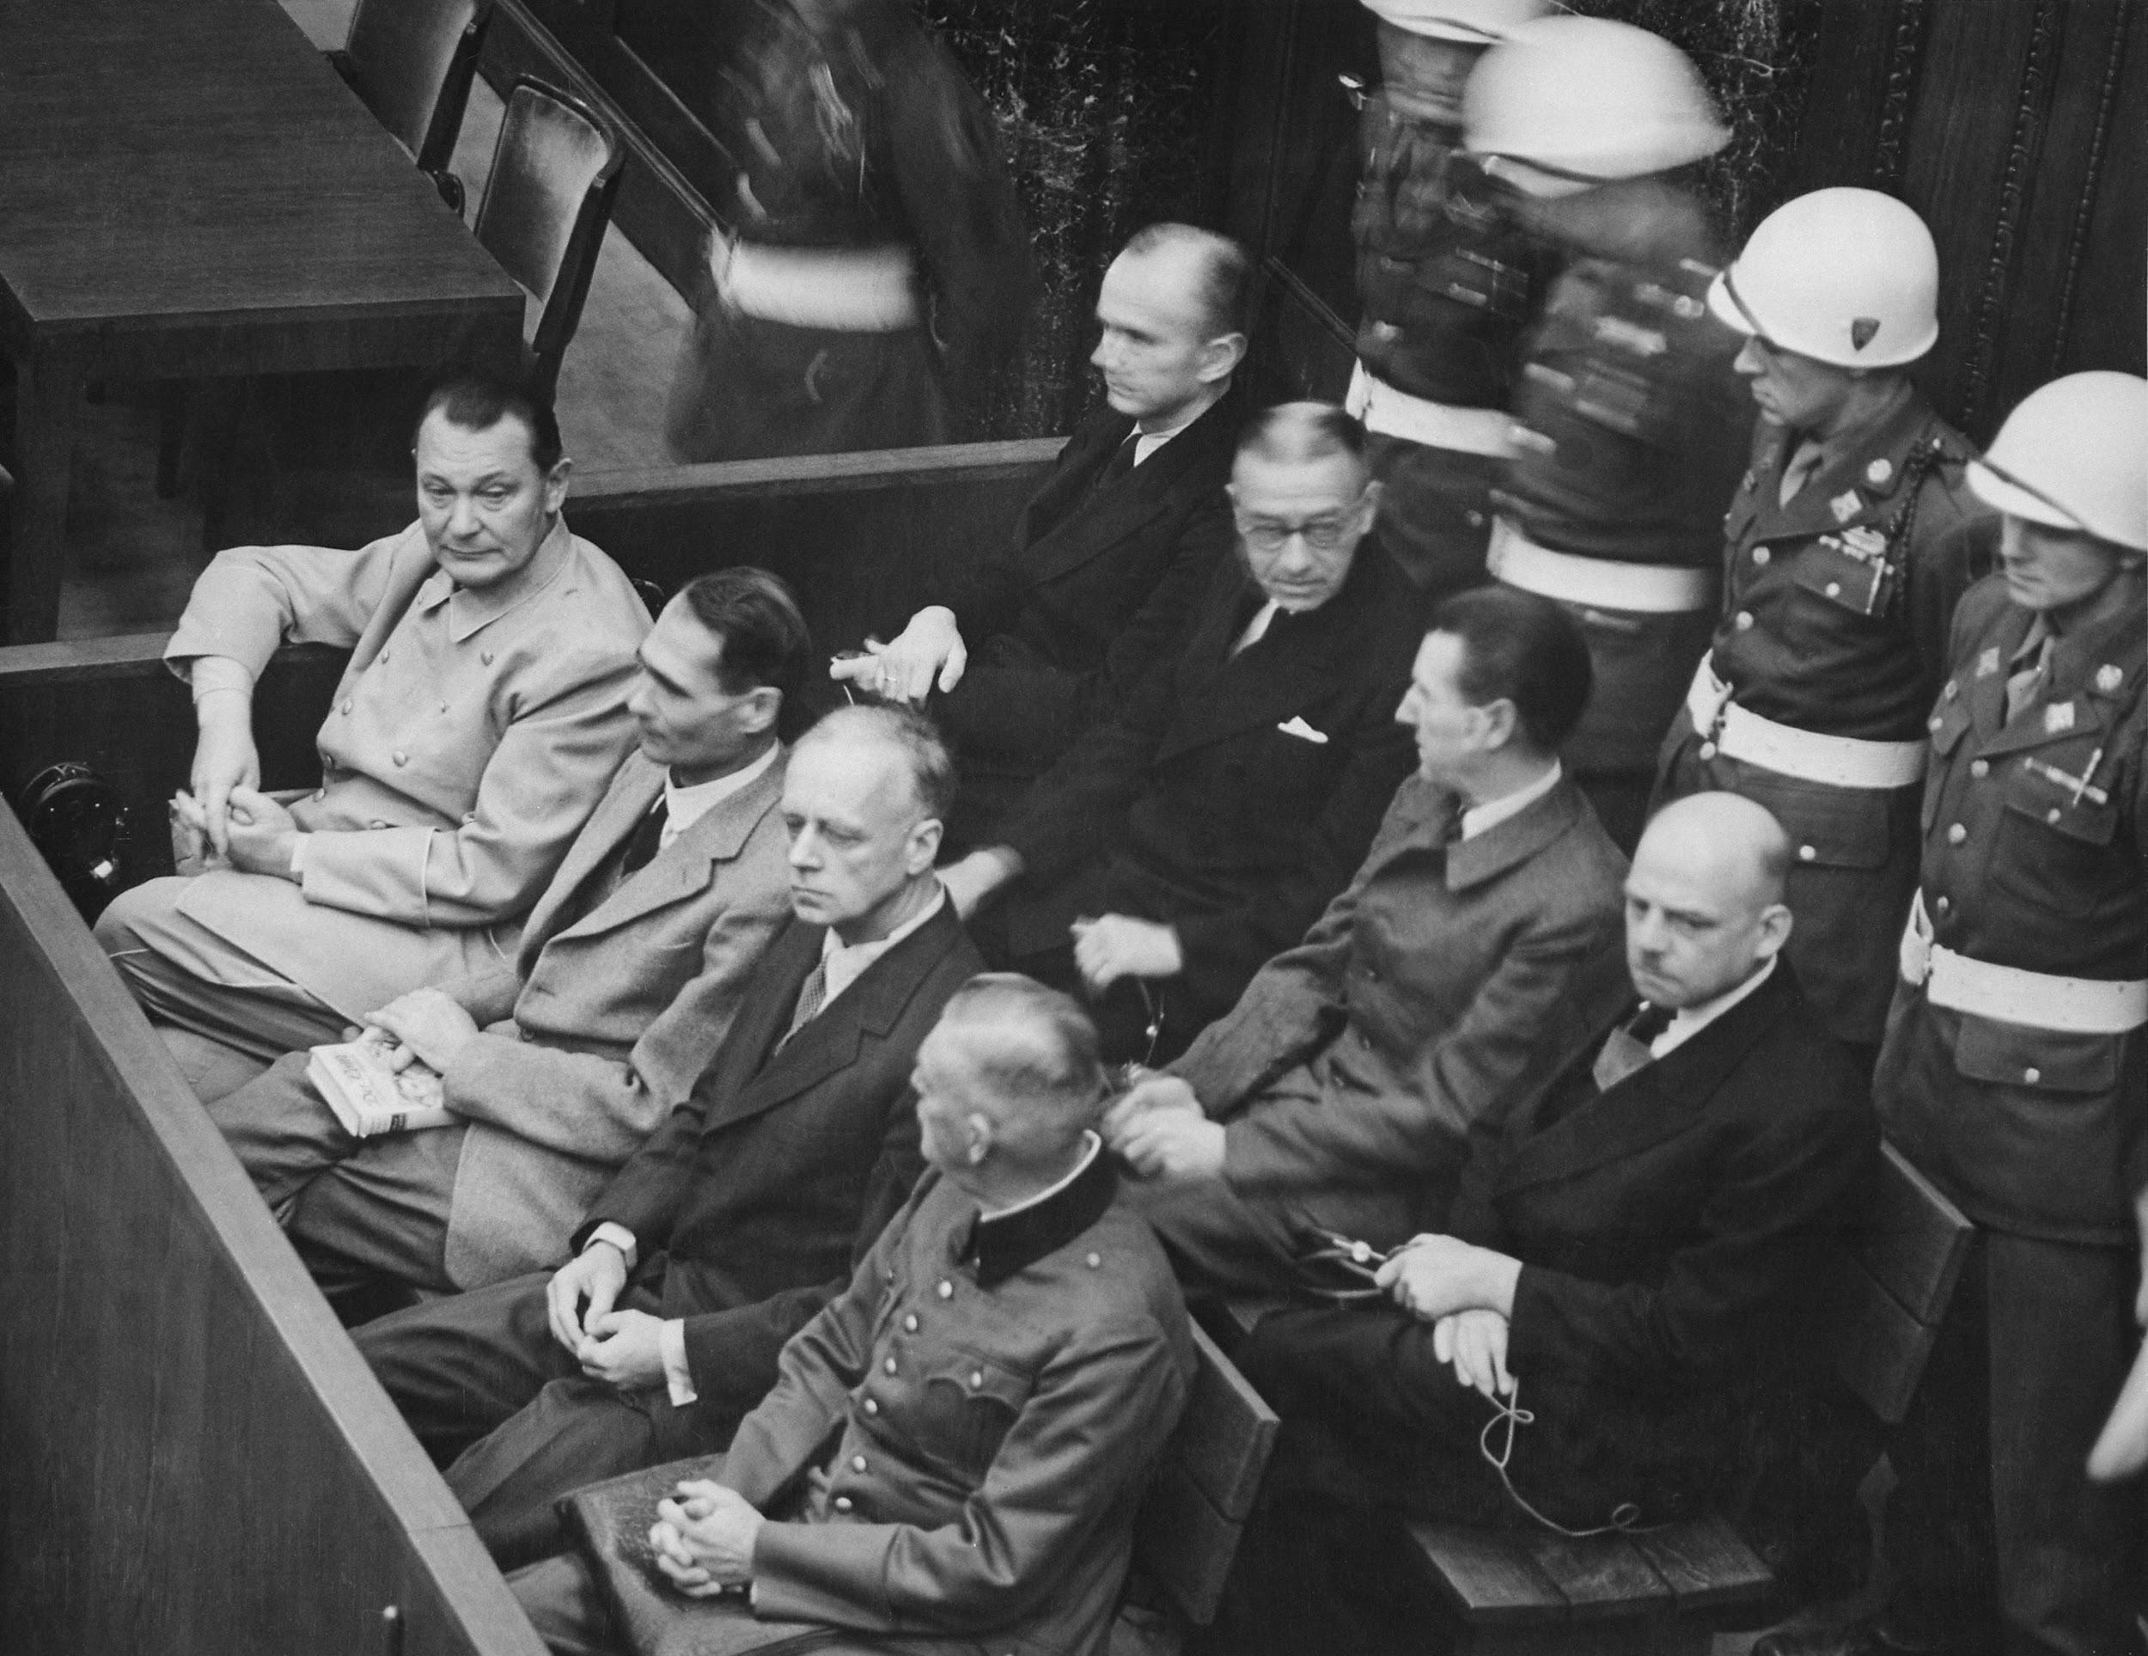
Summary: The Nuremberg Trials were a series of military tribunals held to prosecute Nazi war criminals. Twelve prominent Nazis were sentenced to death. Most of the defendants admitted to the crimes of which they were accused, although most claimed that they were simply following the orders (which came to be known as the “Nuremberg Defense”) of a higher authority. Those individuals directly involved in the killing received the most severe sentences. Other people who played key roles in the Holocaust, including high-level government officials, and business executives who used concentration camp inmates as forced laborers, received short prison sentences or no penalty at all.The Nazis' highest authority, the person most to blame for the Holocaust, was missing at the trials. Adolf Hitler had committed suicide in the final days of the war, as had several of his closest aides. Many more criminals were never tried. Some fled Germany to live abroad, including hundreds who came to the United States.

Trials of Nazis continued to take place both in Germany and many other countries. Simon Wiesenthal, a Nazi-hunter, provided leads for war crimes investigators about Adolf Eichmann. Eichmann, who had helped plan and carry out the deportations of millions of Jews, was brought to trial in Israel. The testimony of hundreds of witnesses, many of them survivors, was followed all over the world. Eichmann was found guilty and executed in 1962 (US Holocaust Museum).
World War II  Sep 1, 1939 – Sep 2, 1945  World War II, also known as the Second World War, was a global war including the vast majority of the world's countries—including all the great powers—eventually formed two opposing military alliances: the Allies and the Axis. | Nuremberg Trials  Nov 20, 1945 – Oct 1, 1946 | Genocide Convention  1948  The Convention on the Prevention and Punishment of the Crime of Genocide was adopted by the United Nations General Assembly on 9 December 1948 as General Assembly Resolution 260. The Convention entered into force on 12 January 1951.

Key Vocabulary:  - Holocaust: a genocide during World War II in which Nazi Germany, aided by local collaborators, systematically murdered some six million European Jews—around two-thirds of the Jewish population of Europe—between 1941 and 1945.  - Genocide: the deliberate killing of a large group of people, especially those of a particular ethnic group or nation.  - War Crime: As initially defined in the Nuremberg Principles, an action carried out during the conduct of a war that violates accepted international rules of war. | Key Individuals:  - Iona Nikitchenko: The Soviet Union’s representative judge at the Nuremberg Trials, including the first session which tried high-ranking Nazis.  - Hermann Göring: Originally the second-highest-ranked member of the Nazi Party and Hitler's designated successor, he fell out of favor with Hitler in April 1945. Highest ranking Nazi official to be tried at Nuremberg. Committed suicide the night before his execution.
Comprehension Questions:  - How many high-ranking Nazi officers were sentenced to death?  - What was the “Nuremberg Defense?”  - What were two major impacts of the Nuremberg Trials? | 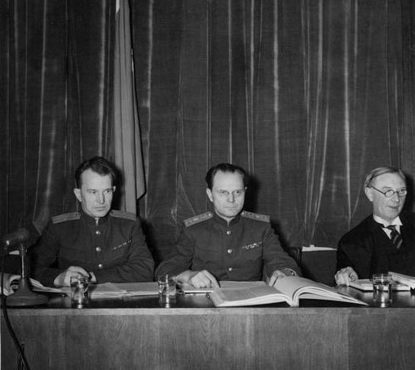
Answer Key:
- Twelve
- “I was just following orders.”
- The development of the Nuremberg Principles and Code.

Historical Controversy: The Nuremberg Defense

The Nuremberg Defense: “I was just following orders”  During the Nuremberg Trials, many high-ranking Nazis argued they had not committed war crimes, as they were “just following orders” of a higher official during the Holocaust. This excuse was used so frequently during the trial that it came to be known as the “Nuremberg Defense.” Although this excuse is indefensible according to the Nuremberg Principles, it is part of a larger historical and legal controversy. Historians and experts still debate if an individual should be held responsible for their crimes if they were following someone else's the orders. | 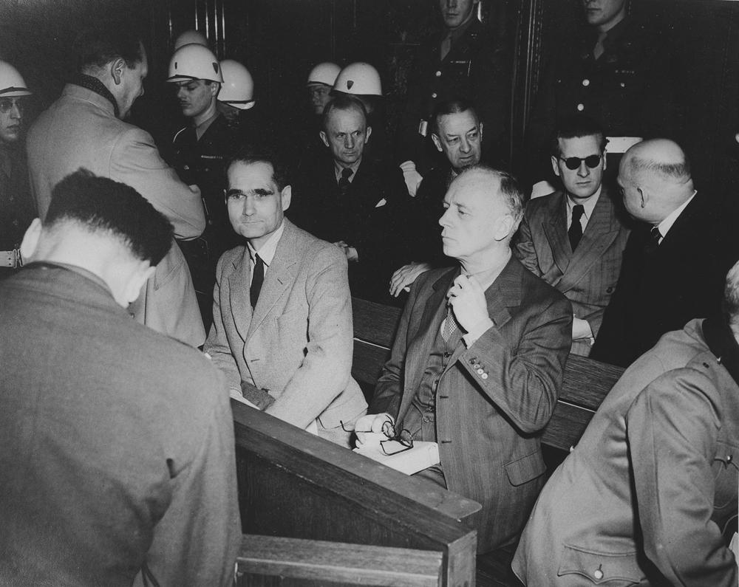
Perspective 1: Following Orders is a Valid Defense  For some, following orders is a valid excuse for many crimes. From this perspective, we must consider the various pressures and influences that might compel someone to follow a unethical order. For example, a low-level Nazi officer may have been afraid for his own life if he defied orders. | Perspective 2: Following Orders Does Not Excuse A War Crime  According to the Nuremberg Principles, established in reaction these trials, following orders does not excuse you from committing a war crime, even if your actions were technically legal or given by a superior power. From this perspective, an individual is responsible for making moral choices, regardless of external factors.
The Nuremberg Trials: Political Comic

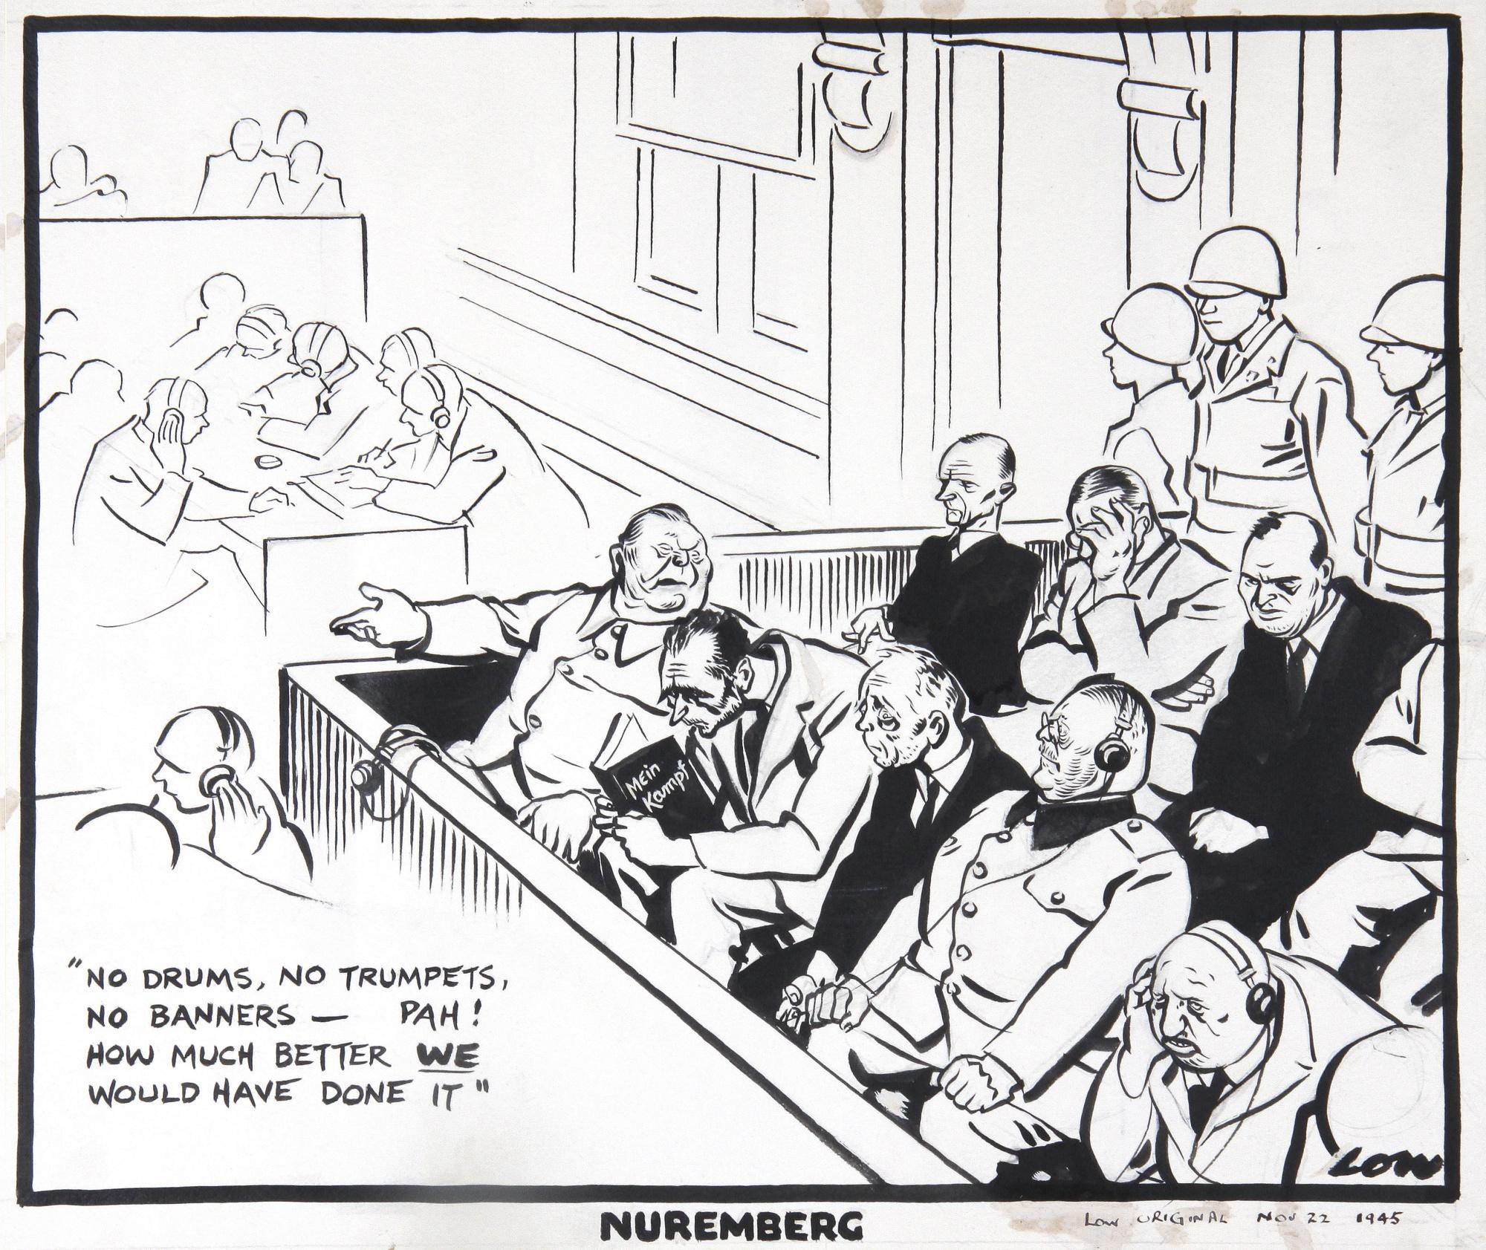 | Contemporary Art: Political Cartoon  The Nuremberg Trials were a major international event. Many people across the world were watching the trial unfold through newspapers. The political comic shown was created by David Low and published in the Evening Standard on November 22, 1945. It depicts several prominent Nazis at the trial, including Hermann Goering, Rudolf Hess, and Joachim von Ribbentropp.
Analysis of Art/Artifact  This comic represents the general lack of remorse shown by Nazi officials. In the image, Goering is seen making light of the serious trials, stating “No drums, no trumpets, no banner...how much better we would have done it!” This is in reference to the Hitler and the Nazi Party’s inclination to stage ostancious and highly performative speeches and political events. Next to Goering, Hess is seen reading Mein Kampf. This is meant to represent Hess’s lack of remorse. Even in the face of the Nuremberg Trials, he is shown still clinging to Hitler’s ideas. | Significance of Art  As it was created during the trials, this comic represents the general perspective of the trials. Particularly in allied countries, these Nazi officials were seen as particularly callous and lacking remorse. Many Nazis tried to excuse their actions with the “Nuremberg Defense.” As depicted in the comics, these Nazi officials were very unsympathetic figures, both at the time and in retrospect.

