100 Years in Berlin-The Evolution of Identity
World History

Instructions: To better understand how historical events of the 20th Century impacted the citizens who lived throughout, you are each going to tell the story of Karl Mueller. Karl was born into a longtime Berlin family in 1900 and experienced the century of change that followed. In this assignment, you are going to attempt to capture how these changes influenced the SPICE realities of the Karl in the form of a series of journal entries. You will complete these journal entries at your table, each member responsible for one era of Karl’s life.

Each entry should be approximately 200-300 words that include:
- A explanation of the current SPICE realities of Berlin and how they impact Karl
- References to a key event that defined the era
- An assessment by Karl of the vibe (zeitgeist) of Berlin during that time.
Relevant Major Events  (One Entry Per) | Scope | Current Map of Germany
World War I | 1900-1919 | 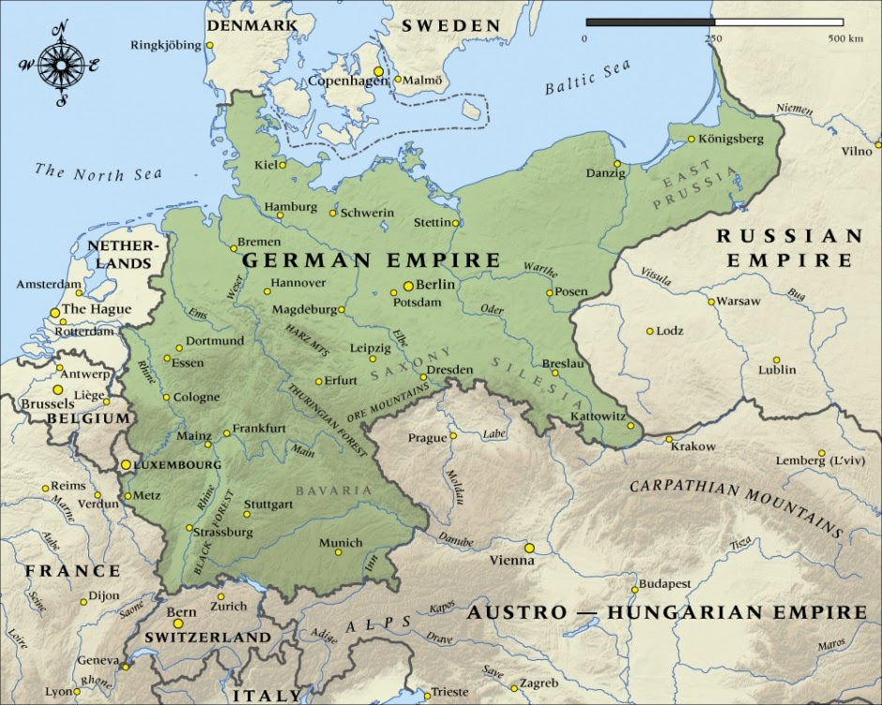
Rise of Hitler and the Nazis | 1929-1939 | 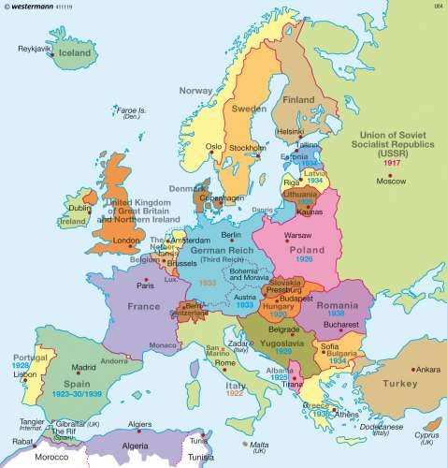
World War II | 1939-1945 | 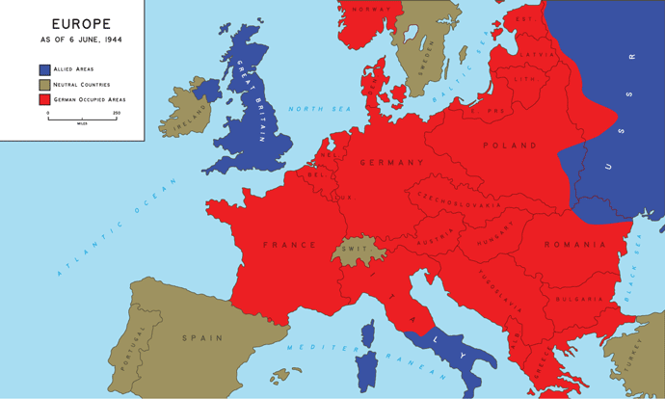
Division of Germany/Establishment of the Berlin Wall | 1945-1949 1961-1989 | 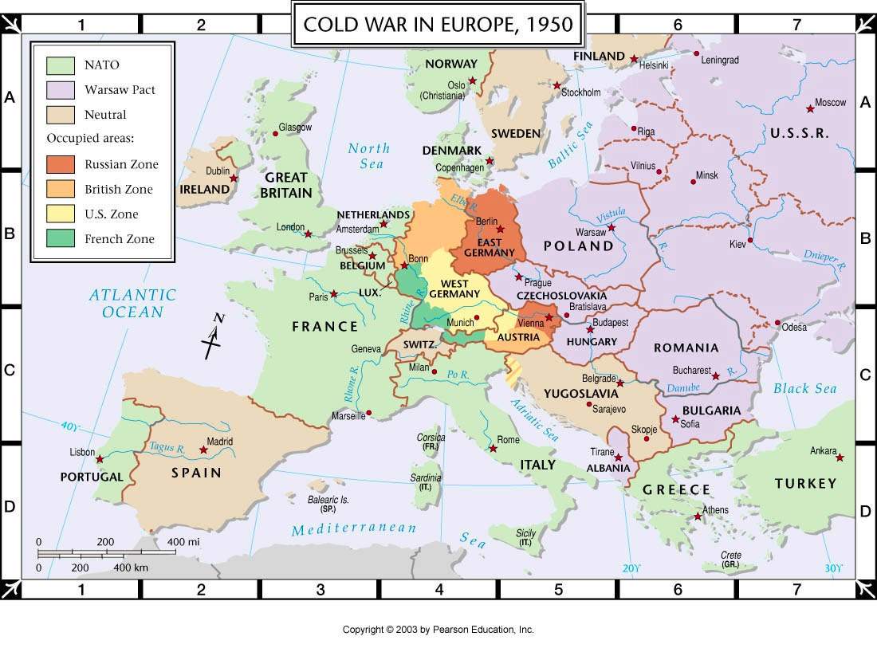  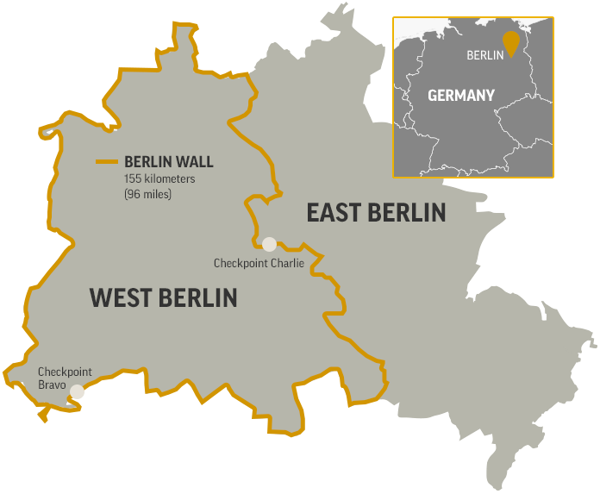
Reunification of East and West Germany | 1989-2000 | 