Deng Xiaoping- The Opening of China World History

Instructions: Use this sheet to take notes on the life and achievements of Deng Xiaoping. When we are finished with the video, we will use the reverse side the compare and contrast his and Mao’s impact on China.

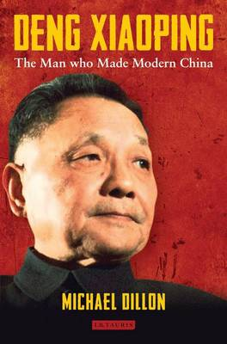

Life of Deng Xiaoping
What was his role in Mao’s Communist Revolution?

What happened to him under Mao’s leadership?

Impact on China
How did he change China move China to a more free market system?

Did he make China a more free society?

