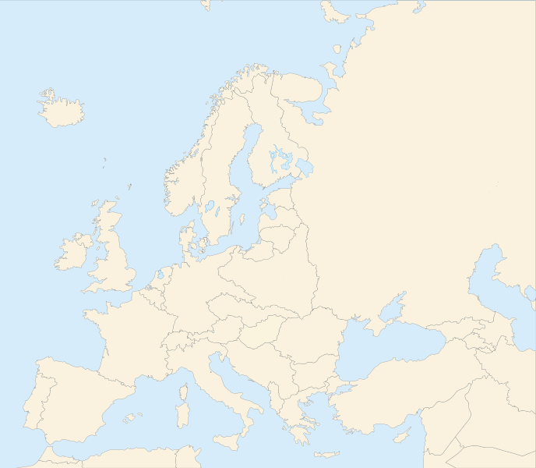
“Hot Spot” Map of the World (Really Europe and the Middle East)-Interwar Years
IB History
Instructions:
In order to understand the variety of potential areas of tension in Europe following the Treaty of Versailles, you are going to each create an annotated map of the continent. In your map you will:
- Label all of the countries and territories that were created as a result of the Paris Peace Conference of 1919.

- Designate areas of potential conflict and give them a rating from 1 to 4 flames (design up to you) depending on the likelihood that they will be a flash point for future conflict. 1 flame being mildly troublesome to 4 being about to explode.

- For each “hot spot” you will need to provide a 1-2 paragraph annotation that that explains the nature of the conflict and justifies your ranking.

- Provide a summary (could be a bullet list) of the treaties of Saint Germaine, Trianon, Neuilly, Rapallo, Severs, Lausanne and the Sykes-Picot agreement. For each treaty, explain how they lessened or increased the level of tension in Europe/the Middle East in the 1920’s.

Your maps are due when you come to class next lesson
Resources:
Your primary resources for this task will be chapters 3,5 and 6 in Goldstein but you are of course allowed to draw upon additional research.

